**SOFTWARE REQUIREMENT ANALYSIS**

**1. Introduction**

## Software requirement analysis is that the full description of the behaviour of the project that need to be developed. It contains certain set of use-cases that will talk about the interactions that the users will be doing with the software. In software requirement analysis it includes all the necessary conditions that need to fulfil in order to get the perfect final end product.

**2. HTML5**

HTML5 is the newest invention of the standard that defines [HTML](https://developer.mozilla.org/en-US/docs/Web/HTML). HTML5 represents two different concepts. It’s a brand-new version of HTML, with new elements, attributes, and behaviours, and new and enhanced tech system which helps to build new webpages and attractive websites. The HTML5 is different from other languages as it covers all the versions of HTML4 and also XHTML, this is different as this language has more syntax and content than any other hypertext language.

HTML5 does everything differently than XHTML as it is different in terms of element, syntax, layouts, tags, formatting and system tools.

HTML5 has more flexibility and compatibility and provides following things −

* Uppercase tag names for better experience.
* Quotes are as per needs
* Attribute values can be attached anywhere.
* Closing empty elements at the end.

**3. CSS**

**Cascading Style Sheets**, usually mentioned as CSS, may be a simple design language intended to simplify the method of creating sites presentable. CSS is very useful when it comes to design HTML documents.CSS describes how HTML elements should be displayed.

**Why CSS: -**

* **Create Stunning Web site** -CSS controls the plan and feel a piece of a web page. Utilizing CSS, you'll control the shade of the content, the plan of text styles, the separating between the sections, how segments are measured and spread out, what foundation pictures or shadings are utilized, format plans, varieties in show for different gadgets and screen estimates additionally as a spread of different impacts..
* **Control web** - CSS is not difficult to learn and see however it gives amazing authority over the show of a HTML archive. Most usually, CSS is joined with the increase dialects HTML or XHTML

**4. JavaScript**

JavaScript is a programming language that adds intuitiveness to your site. This occurs in games, in the conduct of reactions when catches are squeezed or with information section on structures; with dynamic styling; with activity, and so forth JavaScript is adaptable and amateur agreeable. With more experience, you'll have the option to make games, enlivened 2D and 3D designs, thorough data set driven applications, and significantly more..

JavaScript itself is generally minimal, yet entirely adaptable. Engineers have composed an assortment of apparatuses on top of the centre JavaScript language, opening a tremendous measure of usefulness with least exertion. These include:

* Browser Application Programming Interfaces (APIs) incorporated into internet browsers, giving usefulness, for example, powerfully making HTML and setting CSS styles.
* Third-party structures and libraries that you can apply to HTML to speed up crafted by building locales and applications.

**5. APIs (Application Programming Interface)**

Programming interface represents Application Programming Interface. In essential terms, APIs are a bunch of capacities and methodology that consider the making of uses that entrance information and highlights of different applications, benefits, or working frameworks. The API isn't the data set or even the worker, the code oversees the entrance point(s) for the worker.

**Types of APIs**

There are four main APIs that everyone is using now a days:

1. Open APIs which can be used by anyone who wants to add them to their websites.
2. Partner APIs, these are those in which some users and businesses come together to use features of this API in form of tickets and vouchers.
3. Private APIs, these APIs are not for the normal public and common users, these are internal APIs which are used by defence system and confidential systems.
4. Composite APIs, these APIs are used to combine data of multiple rounds to a single call API.

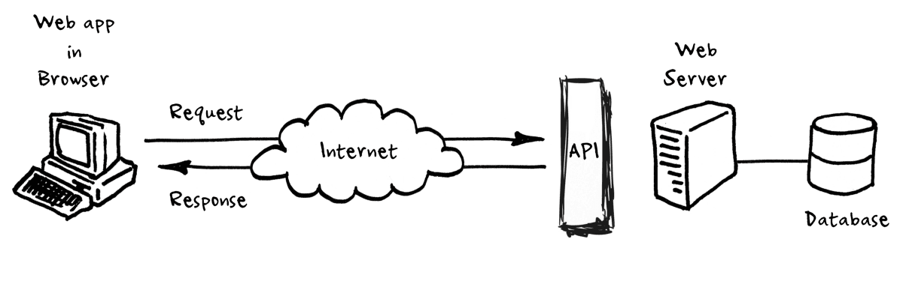

**DESIGN**

Software design is a process in which user tells prototyped raw information and every possible aspects for the software to perform well, design is like a blue print which helps the developer avoid any mistakes. Design is really defined as a multistage levelled process.

Stages from which our project went are:

* Choosing correct layout for website
* Designing webpages
* Collection of knowledge from various portals for Farmers
* Functionality test
* Navigation selection
* Testing for any errors
* Combining all pages together

**1. Choosing correct layout for website**

A website layout may be a pattern that describes a website’s structure. it's the role of making the knowledge present on a site both for the website’s owner and for users. It provides clear paths for navigation within webpages and can drive a user from great experience to all the access to complete website for user and the client as well.

St1. Use a header for document or a neighbourhood <header>

St2. Define a group of navigation links

St3. Sectioning of document for better understanding

St4. Define or use a footer permanently looking layout ending

St5. Use summary to conclude the layout design

**2. Designing a webpage**

A web page is a hyper text mark-up language page which is created to access different content for which a user can gain any knowledge presented in the page and also displayed in every interactive page joining which results in great websites.

St1. Define about the introduction of page

St2. provides a structure to the HTML page

St3. Tags and element

St4. Text formatting for nice styling of texts

St5. Attributes, hyperlinks for user

St6. Inserting images for better understanding of website content

**3. Collection of knowledge for farmers**

In this project we collected data from various means, from newspaper articles to unofficial surveys. Firstly, we collected data of the farmers who wanted to understand about mandi rates, then we collected data for those farmers who wanted to understand about all the govt schemes present out there.

We also searched through government portals for data which may help farmers like major crops a farmer should use during a particular season to urge good yield.

**4. Functionality test**

This step we tested function of our website like:

* Working of links
* Reaction time for webpages to leap on another
* Working of helpline numbers
* Image quality
* Webpage colour frames.

We tested each and each feature of our webpages separately even before assembling all of them together and each time once we found a bug or some error, we corrected it to urge best website out which is straightforward to use and understand.

**5. Navigation selection**

There are various websites present in all over the world now and for each small work there is a website now a days and to use those websites one need to understand the functionality of the particular website. When a website is accessed one needs to navigate every section of the website and for that the navigation section must be easy to use and less complicated because of what the user could easily navigate through the content present there, also the user and navigation section relationship plays a vital role here as the website could be big and long, in mean time if a user wants to jump directly to the last page of website, the navigation must help user to gain access and content.

**6. Testing for any errors**

When we did our functionality testing it had been for outer look, links of website now we performed testing to understand if website will work perfectly to each system? Will it show exactly same text(font-colour) whenever employed by any individual? and that we got all our answers and that we made some amendments too. While testing for errors our main focus was to take care of quality of website (image quality, text quality, content, maps).

When creating this website, we ensured that our website is easily adaptive to new browsers and different OS, and also with different desktop versions it could perform well and good.

**7. Combining all pages together**

When we started creating this website from start, we were using visual studio code and that we created all the webpages therein, moreover while we were finished making all the required pages, we assembled them using visual studio code. This application is great for creating webpages with inbuilt header and selectors.

We combined all the pictures, icons, CSS files, javascript files in one folder and every one the webpages from index.html to mandirates.html within the same folder.

Finally, after debugging it we got our final outcome this website.

**Data flow chart for our website**

